Promoted for and on behalf of Cycling Time Trials
under their Rules and Regulations

Farnborough & Camberley CC
10 Mile Time Trial
Saturday March 5th at 10.00 a.m.
(sign-on from 09.00 a.m.)

EVENT SECRETARY: Gavin Watson
2 Harvey Road ,
Farnborough, Hampshire
GU14 9TW
Tel: 07958442501
Email: bikeswimcoachwatson@gmail.com
TIMEKEEPERS: Donald Ashton (Farnborough & Camberley CC) and Mark Ashton (Farnborough & Camberley CC)
HEADQUARTERS: Bentley Memorial Hall, Hole Lane, Bentley GU10 5NB

IMPORTANT NOTES

- COVID update – NO Covid restrictions but if you have symptoms please don’t attend . Please follow government guidline.

- Refreshments will be available please bring change to contribute to cost

- REAR LIGHTS ARE NOW COMPULSORY – Cycling Time Trials Regulation #14(i) states “No competitor shall be permitted to start either a Type A or Type B event unless such competitor has affixed to the rear of their machine a working rear red light, either flashing or constant, that is illuminated and in a position that is clearly visible to other road users.”

- Please respect the local residents of Bentley by parking considerately. Do not park on the road near the headquarters, even for a short period of time. Please adhere to the guidance on the parking notes and diagram included below. If we receive complaints, we may lose Bentley Memorial Hall as an option for the HQ. This could potentially mean the end of up to 20 open events on the course during the year.

- Please respect the volunteers from Farnborough & Camberley CC and the timekeepers who are giving up their time to help out.

- Please sign on and collect your numbers from the headquarters.

- Position your number so that it is visible from the rear when in the racing position.

- This event may be subject to a Doping Control - It is your responsibility to check by returning to the HQ and signing out as soon as possible after you finish. A rider who fails to sign the official signing-out sheet shall be recorded as DNF - CTT Regulation #17(b)
- Please return your numbers to HQ when you sign out, where they can be exchanged for refreshments after completing the event.

No cleats or bikes are allowed in the hall.

- Please allow at least 10 minutes to get to the start.

- The start is on the opposite side of the carriageway from the HQ. Riders should only use designated crossing points and must not climb over the central reservation. Anyone seen doing so will be disqualified from the event.

- Head-down riding kills – if dangerous riding is witnessed it will be investigated and reported.

- No vehicles, except those of the timekeepers and event volunteers, shall be parked at the start or finish

CAR PARKING

Car parking is available at the HQ and in the lay-bys past the finishing point as highlighted in green in the map below.
DO NOT park in the areas highlighted in red in the map below and if parking in River Road please ensure you only park on the grass verge, keeping the footpath and bus stop clear. As stated below do not park on the eastern side of River Road between Main Road and the bridge over the A31.
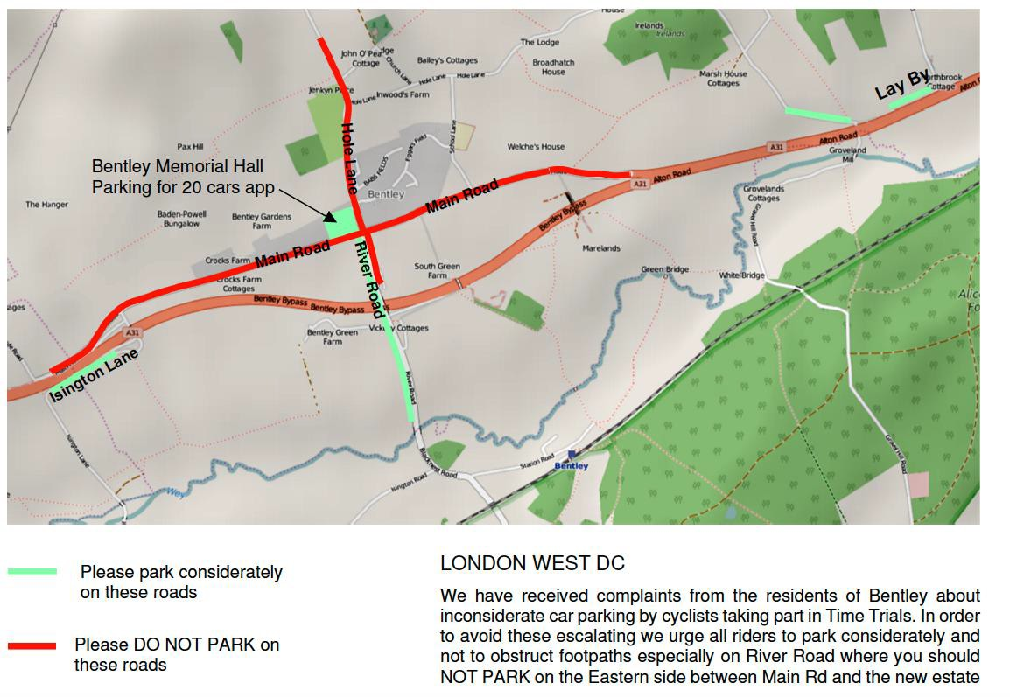
DIRECTIONS TO THE START

To reach the start from the HQ in Bentley, go eastwards through the village to join the A31, cross to the right hand lane after 850 yards (there are lane markings) and then cross over to the South side of the A31 at the Gravel Hill road junction just short of the old ‘Bull’ Public House and continue westwards for 760 yards to the lay-by start point.

COURSE DETAILS

H10/8 Bentley – Holybourne – Bentley 10 miles (OS map 186)

OS Map Ref
796442 START at a point in the lead out onto the A31 from the lay-by on the south side at the commencement of the Bentley by-pass, approximately 800 yards west of the Bull Public House on the north side of the A31 and 5 yards beyond the last but one drain grating and 25 yards short of the large road direction sign marked 'BENTLEY ½m'. 0.000 miles
736403 Proceed (Care) to join the A31 and continue to go Westwards along the Bentley by-pass through Froyle to the Holybourne roundabout (Turn) 4.702 miles
802443 Circle the roundabout and take the third exit back on to the A31 to retrace, going through Froyle and along the Bentley by-pass to a point 10 yards beyond the concrete end of a water culvert on the North side and 63 yards short of the Gravel Hill Road minor crossroad and 163 yards short of The Bull to where FINISH 10.000 miles
(Distance between start and finish is 697 yards)
Course link: https://www.cyclingtimetrials.org.uk/course-details/h10-8

COURSE NOTES

The normal dual carriageway of the A31 has been reduced to a single lane at a point approximately three miles westwards from the start. The left-hand lane has been cross-hatched for a distance of approx 400 yards to finish at a point opposite the Petrol filling station just beyond the Hen & Chicken Public House situated on the north side of he A31.
Returning eastwards from the Holybourne roundabout on the north side of the A31 the road has been reduced to a single lane by road cross-hatching on the right hand lane commencing approximately 220 yards before the junction to Mill Court on the south side and finishing adjacent to the Hen & Chicken Public House on the north side.
Competitors are to act in a manner appropriate to competing on a single lane road whilst within the restrictions imposed by the road cross-hatching area.

After finishing, riders must not stop but continue to one or other of the central reservation breaks, cross over with great care and go westwards passing the start point lay-by and along the Bentley by- pass to fork left onto the slip road signposted ‘Bentley’. Turn right at the ‘T’ junction to the Bentley Memorial Hall which you can see ahead of you.

IN THE INTERESTS OF YOUR OWN SAFETY

Cycling Time Trials and the event promoters strongly advise you to wear a HARD SHELL HELMET that meets an internationally accepted safety standard.

There will be marshals and checkers but it is your responsibility to make sure you know the course.

PRIZES
1st Fastest Male £25 2nd Fastest Male £20 3rd Fastest Male £15
1st Fastest Female £25 2nd Fastest Female £20 3rd Fastest Female £15
1st Fastest Vet on Std £20 2nd Fastest Vet on Std £15 3rd Fastest Vet on Std £10
1st Junior/novice award £15
Laterne Rouge £10
Fastest Tandem £10

